Little Champs, 1025 South De Anza Blvd., San Jose, CA 95129
Sunday, May 11, 2014 (starts at 11:30 am)
United States Federation rated Chess Tournament for beginners and intermediate players!
Awards: trophies and prizes!
Refreshments (juice, water) provided

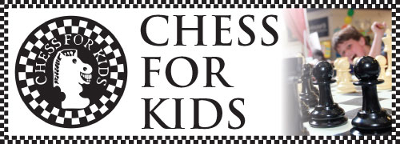

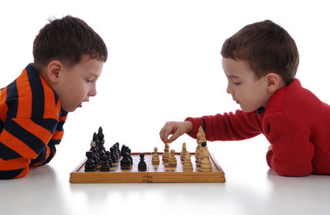
Chess is fun, and playing the game teaches responsibility, improves discipline, and sharpens thinking skills. It also builds confidence and helps young people make new friends.
The tournament format: Quads -- 4 person sections by similar level. Play the other 3 in your quad (every player will play min 3 games with time control 30 min per game per each player)
Must be current/new United States Chess Federation Member (fee is $17/per year).
The Tournament fee is $28 before 04/27, $33 after. Fee is not refundable if canceled less than 48-hr before the tournament. Please bring your set and chess clock.
We may have a separate tournament the same time with prizes for parents (if more than 3 parents will play). The fee is $12. Additional prize – trophy for the best CHESS FAMILY (kid's points and parent's points will be combined)
To register (required): email with subject line “Tournament Registration” and your child’s full name/age, and rating if any to veksler@sbcglobal.net (Tournament Director, Alex Veksler).

